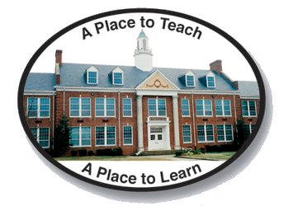
Dinwiddie County Public Schools
2016 – 2017
Budget Goals

The School Board goals for the fiscal year 2017 are as follows:

Goal 1
Offer competitive salaries and benefits to recruit and retain highly qualified teachers, administrators, and support staff.

Goal 2
Ensure all learners demonstrate the 21st-century learning and technology skills and knowledge that will prepare them for success in school, postsecondary education, work and life in a global society.
Goal 3
Provide safe, secure, and nurturing environments for students and staff.

Goal 4
Allocate the financial resources necessary to maintain class ratios and provide multiple remediation opportunities for students in schools not meeting federal AMO or state Standards of Learning.

Goal 5
Foster a strong partnership with the County Government to fund identified short-and long-term capital improvement priorities.

